1. **Install and Configure the MQTT Broker on a Raspberry Pi 3:**

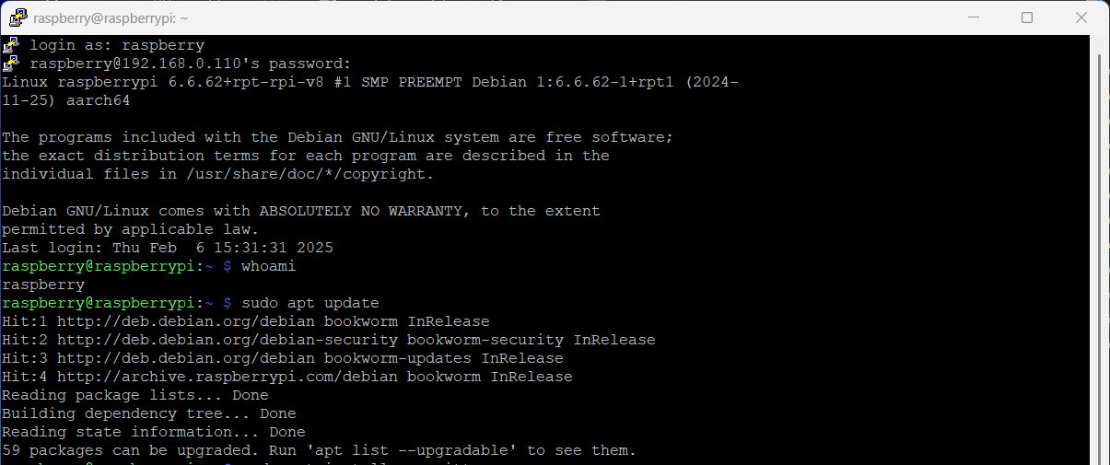

Fig. 1. Screenshot of updating the Raspberry Pi's package list

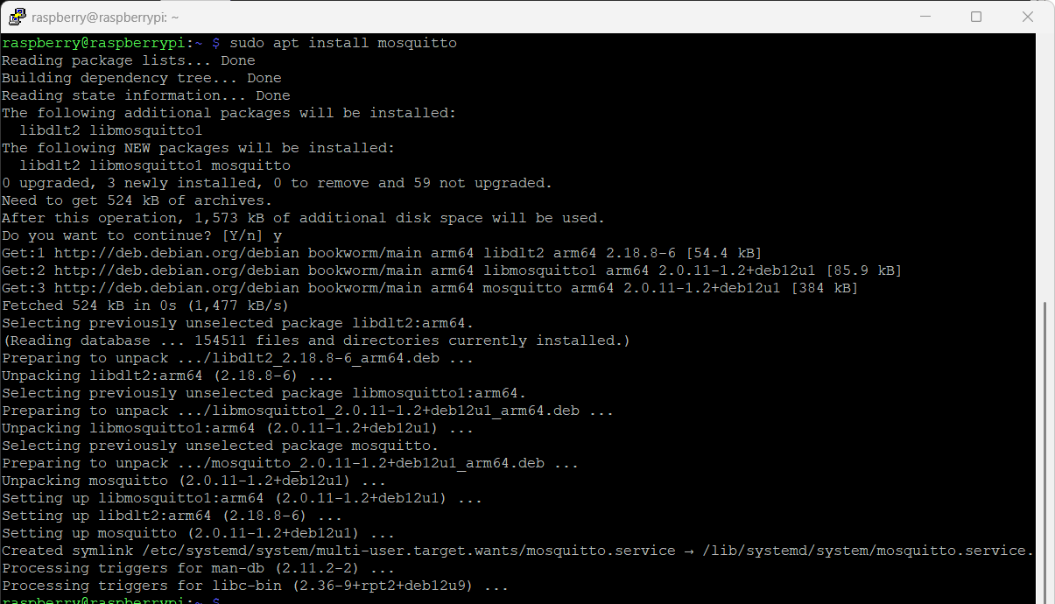

Fig. 2. Screenshot of installing the Mosquitto MQTT broker

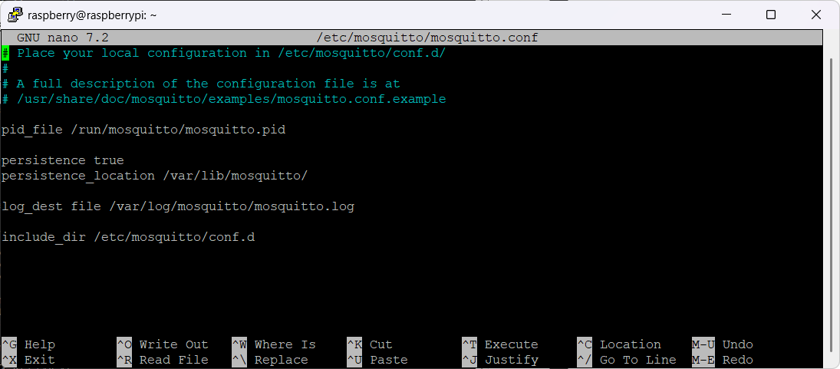

Fig. 3. Screenshot of Mosquitto Configuration File

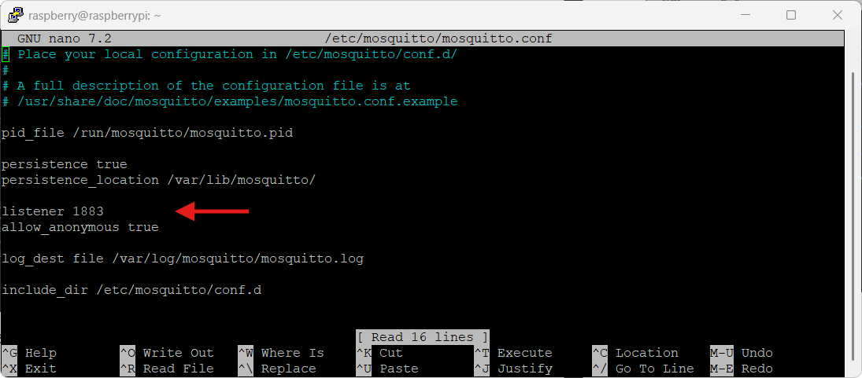

Fig. 4. Screenshot of Mosquitto Configuration File (after allowing broker to listen to port 1883 and allow anonymous clients to connect and use the MQTT broker)

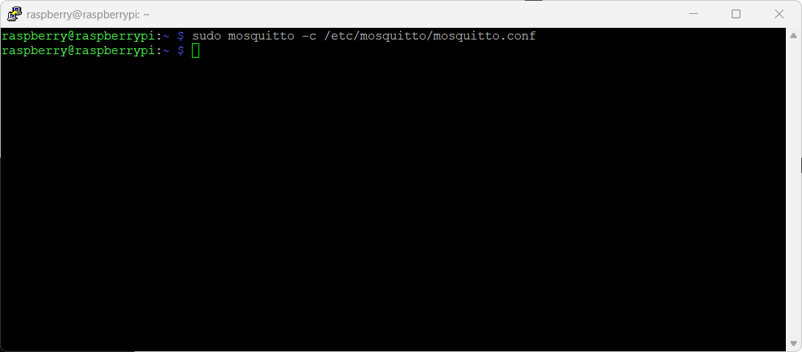

Fig. 4. Screenshot of starting mosquito broker manually via command line

1. **Enable Mosquitto Broker to run on boot**

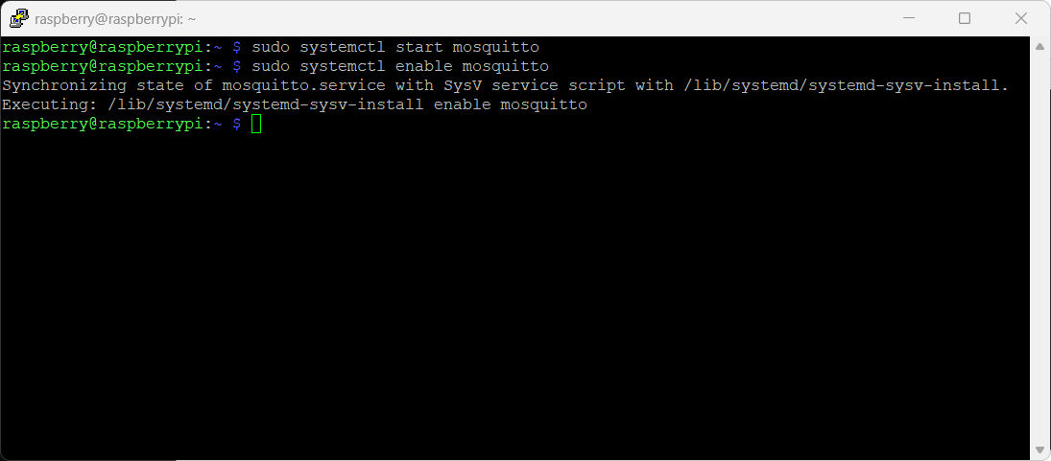

Fig. 5. Screenshot of starting and enabling Mosquitto to run on boot

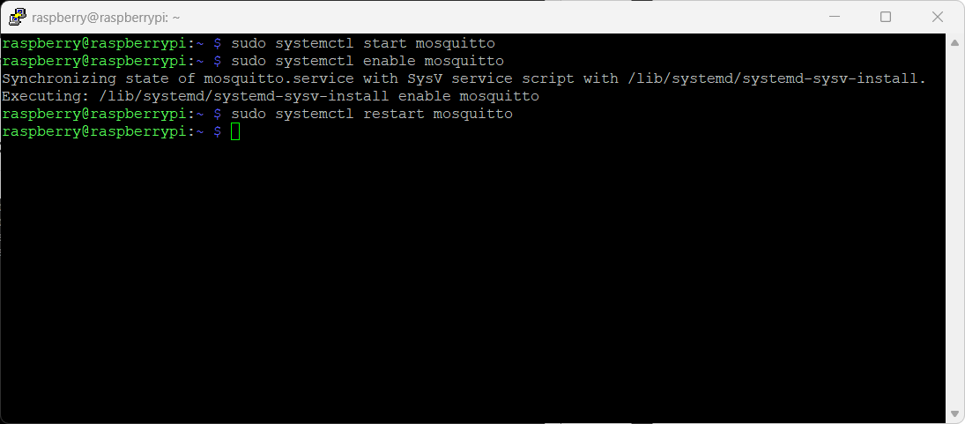

Fig. 6. Screenshot of restarting Mosquitto Broker to apply the new configuration

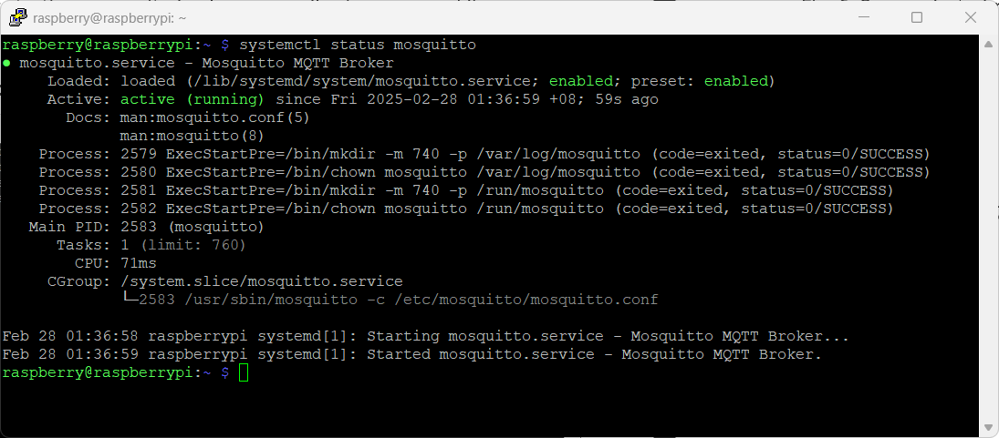

Fig. 7. Screenshot of Mosquitto running status

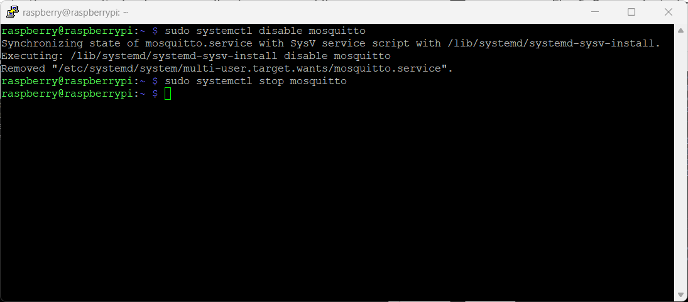

Fig. 8. Screenshot of disabling and stopping Mosquitto MQTT broker

1. **Install and Configure the MQTT Client (Publisher and/or Subscriber) on another Raspberry Pi 3**

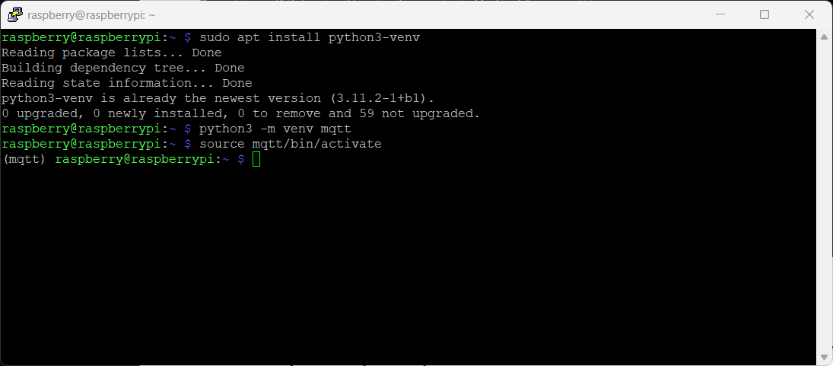

Fig. 9. Screenshot of activating the Virtual Environment mqtt

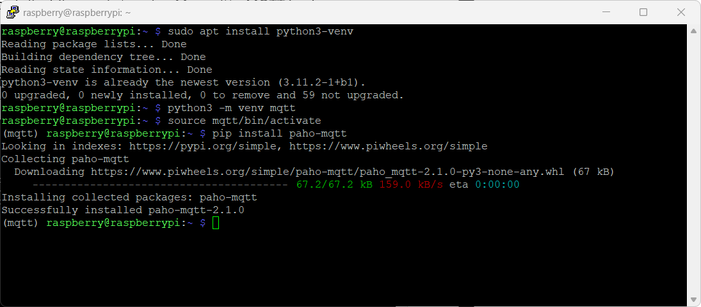

Fig. 10. Screenshot of installation of Python Paho MQTT library for both publisher and subscriber

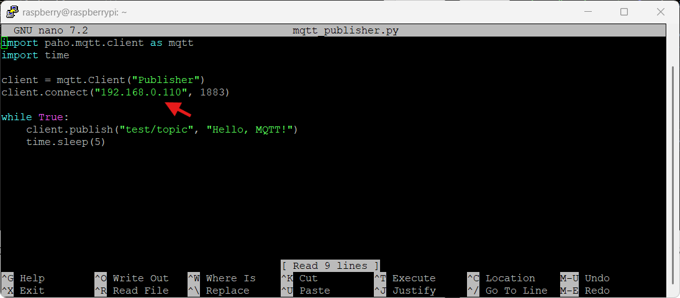

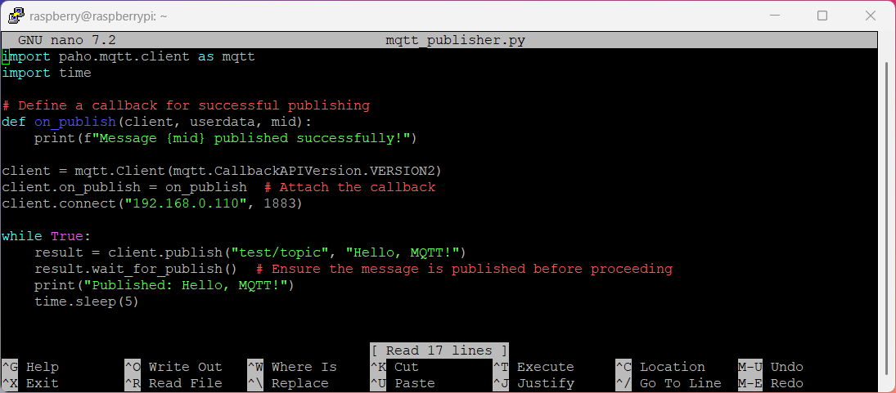

Fig. 11. Screenshot of the Python Script for the MQTT Publisher mqtt_publisher.py with the address changed to the broker’s IP address.

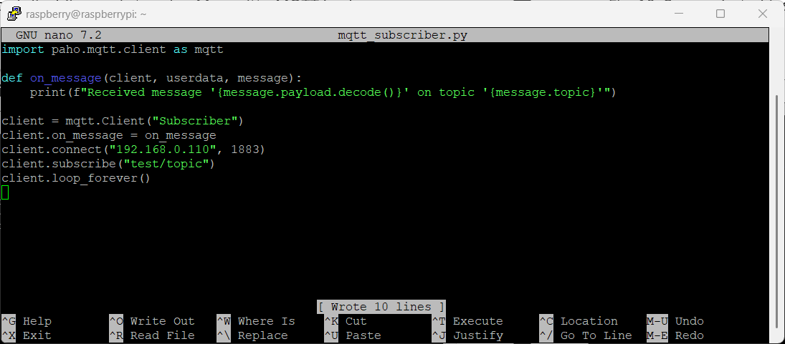

Fig. 12. Screenshot of the Python Script for the MQTT Scriber mqtt_subscriber.py with the address changed to the broker’s IP address.

1. **Testing your MQTT Communication**

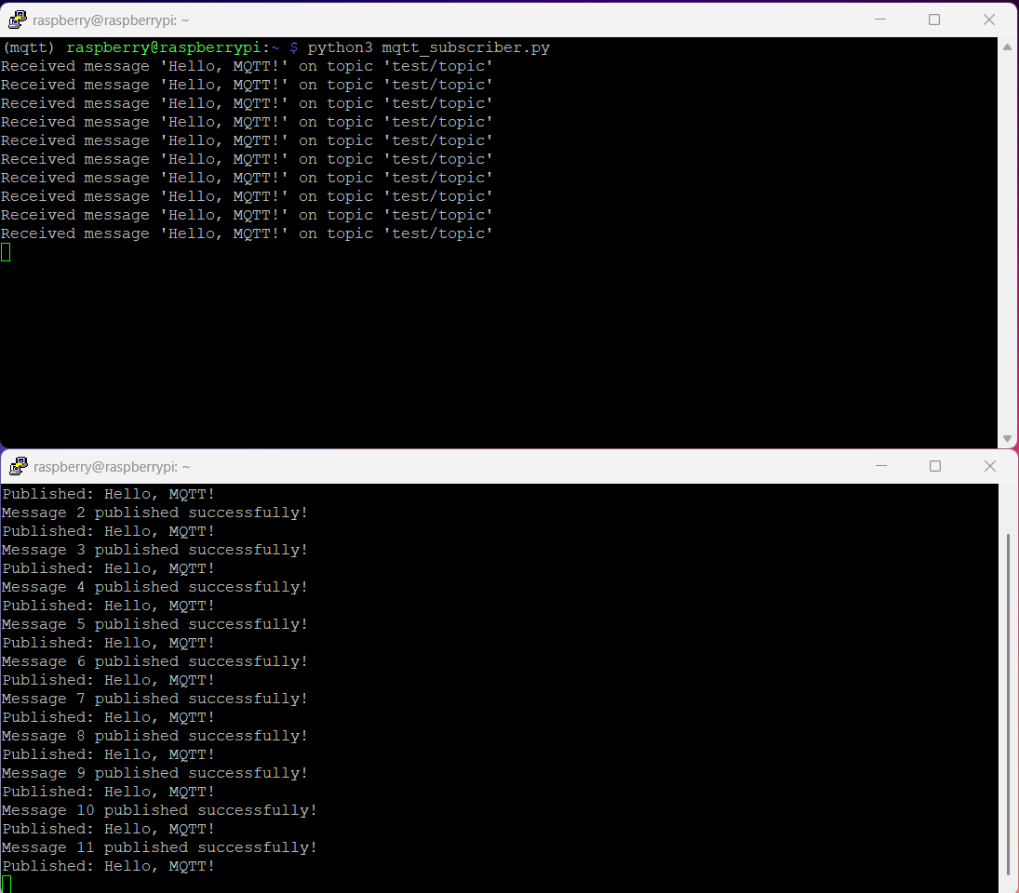

Fig. 13. Screenshot of the messages being published and received in each terminal

1. **Lab Assignment (Did together with Wyvern Khiang 2200577)**

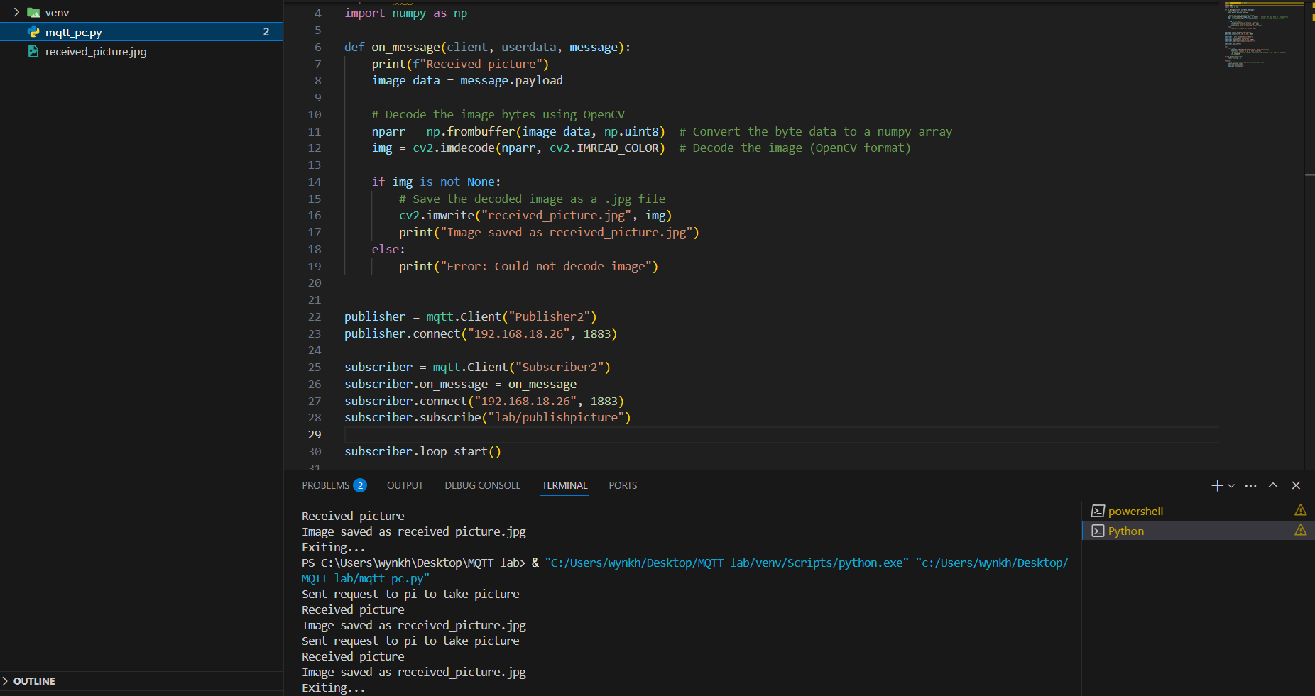

Fig. 14. Screenshot of the code for MQTT

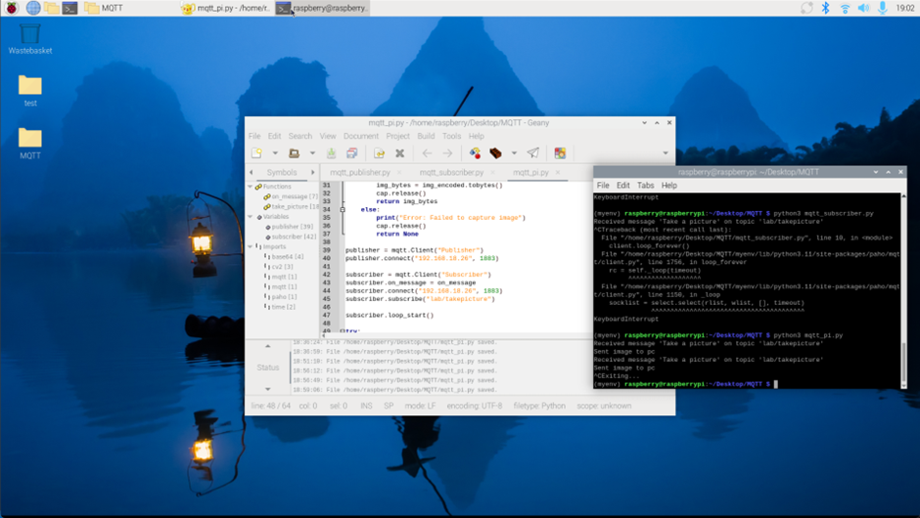

Fig. 15. Screenshot of publisher taking webcam screenshot in the background and sending to the MQTT broker

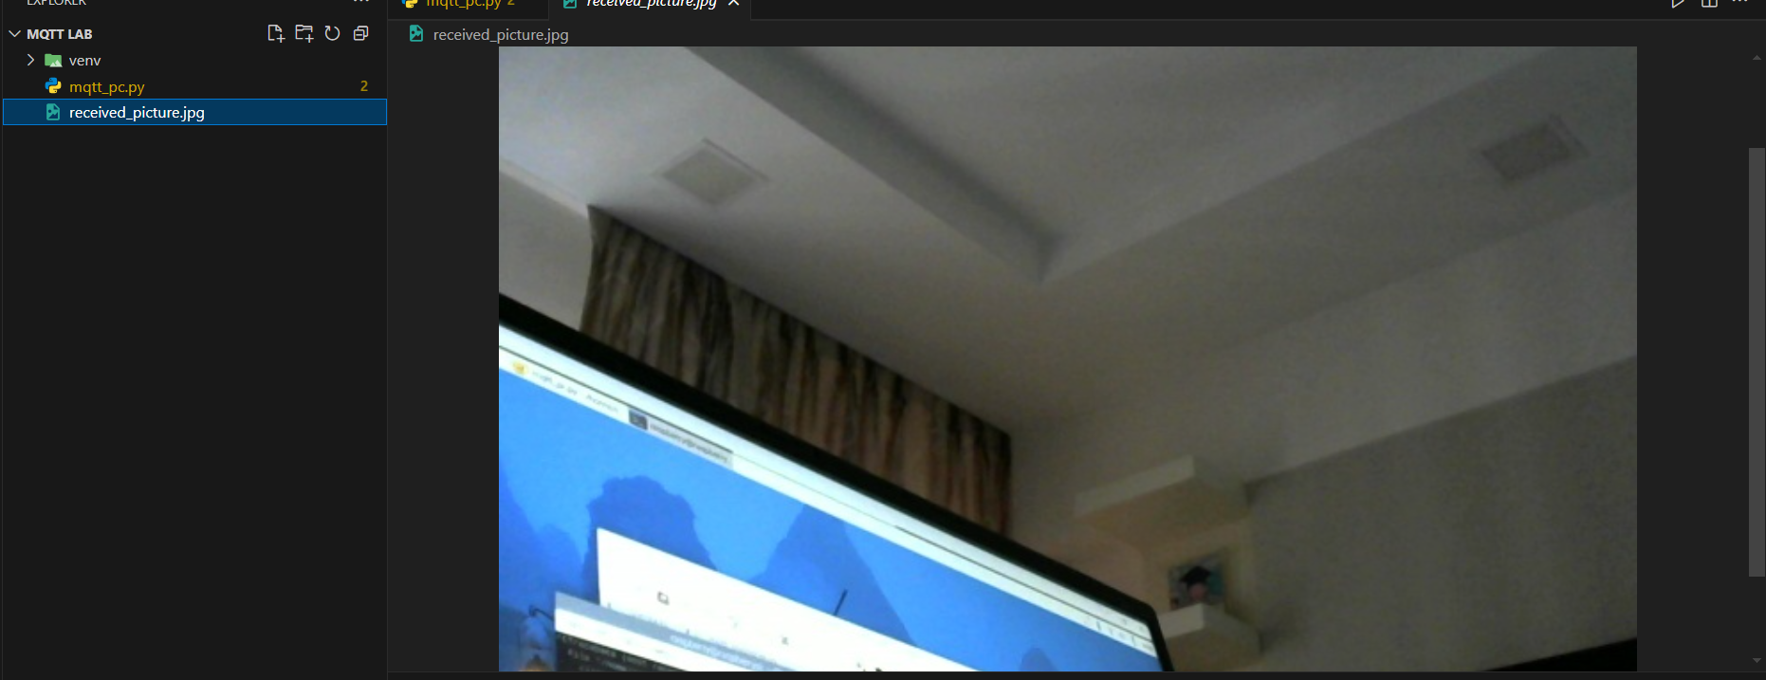

Fig. 15. Screenshot of image received by the subscriber from the MQTT broker